Batch: E-2 Roll No.: 16010123325

Experiment / assignment / tutorial No. 3

Grade: AA / AB / BB / BC / CC / CD /DD

Signature of the Staff In-charge with date

Title: : Implementation of Database in SQL -DDL

Objective: Define/modify database definitions with proper constraints
_____________________________________________________________
Expected Outcome of Experiment:
CO 2: Convert entity-relationship diagrams into relational tables, populate a relational
database and formulate SQL queries on the data Use SQL for creation and query the database.

CO 3: Define and apply integrity constraints and improve database design using normalization techniques.
_______________________________________________________________________
Pre Lab/ Prior Concepts:
Resources used: Postgresql

Theory: The set of relations in a database must be specifies to the system by means of a data definition language (DDL). The SQL DDL allows specification of not only a set of relations but also specific information about the relation including,
- The schema for each relation
- The domain of values associated with each attribute
- The integrity constraints
- The set of indices to be maintained for each relation
- The security and authorization information for each relation
- The physical storage structure of each relation on disk

Syntax Create Table:
create table employee(ssn,fname varchar(10), mname varchar(10), lname varchar(10), desg varchar(20), gender varchar(5), addr varchar(20), bdate datetime, sal float,primary key(ssn));
create table manages(ssn int, dept_code int, start_dt datetime, foreign key(ssn) references employee, foreign key(dept_code) references department, key(ssn,dept_code) ) on delete set null

Data Constraints
Business managers of the organization determine a set of rules that must be applied before the data is stored in the database. The application of such rules on raw data ensures data integrity.
Eg:- An employee belonging to the Sales department cannot have a salary higher than Rs. 1000.
An employee has an unique identification number.
Applying Data Constraints
Oracle permits data constraints to be attached to table columns using SQL syntax. Constraints can be attached to table columns using Alter table.
Unique Constraint
Unique Constraint- At column level Syntax
<ColumnName><Datatype>(<size>) UNIQUE
Unique Constraint- At table level
CREATE TABLE<TableName>(

<ColumnName><Datatype>(<size>)

<ColumnName><Datatype>(<size>)

<Columnname><Datatype>(<size>) UNIQUE(<ColumnName1>,<ColumnName2>);

Implementation Details (Problem Statement, Query and Screenshots of Results):

Problem Statement
The problem revolves around designing a database for a Hospital Management System. It
manages patient details, doctor information, department allocations, hospital bed
assignments, appointment scheduling, medical records, prescriptions, and billing details,
while maintaining essential constraints, specializations, generalizations, and relationships
to ensure accurate and efficient management of hospital operations.
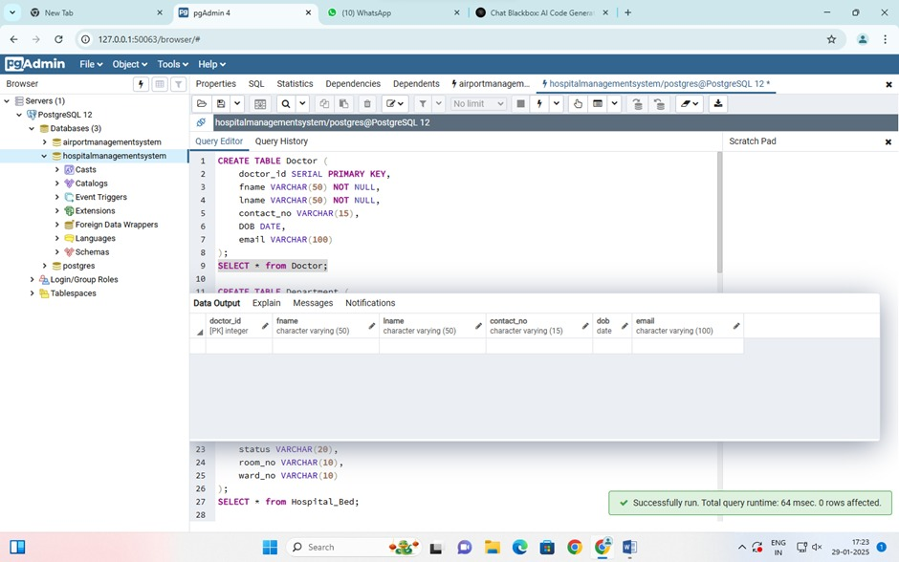
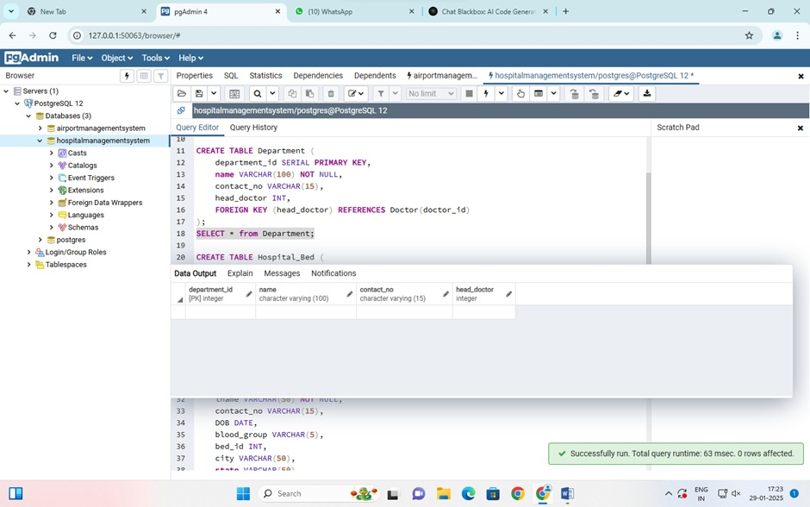
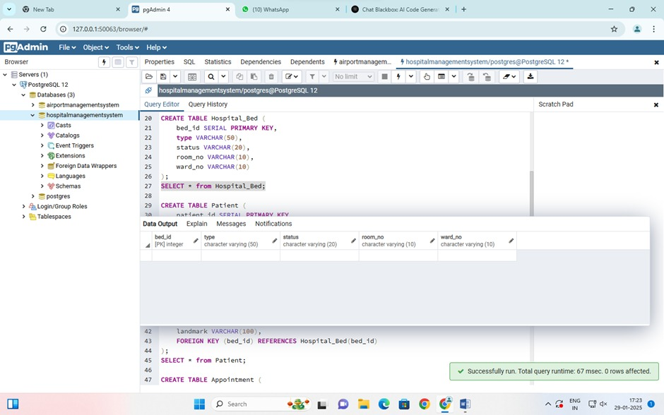
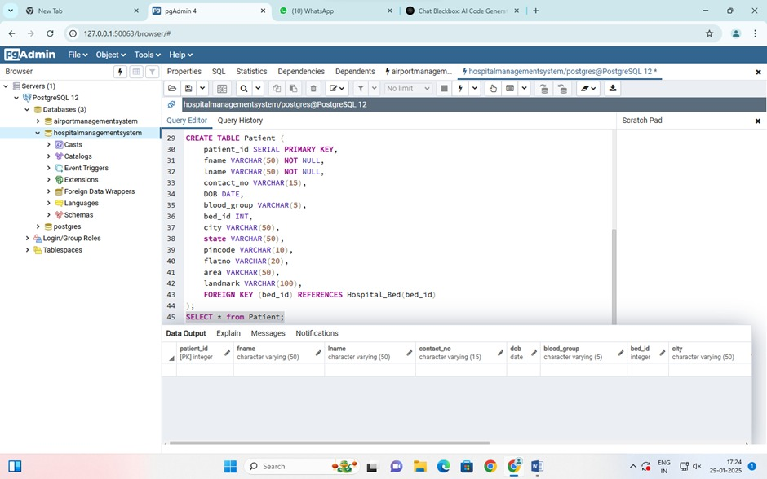
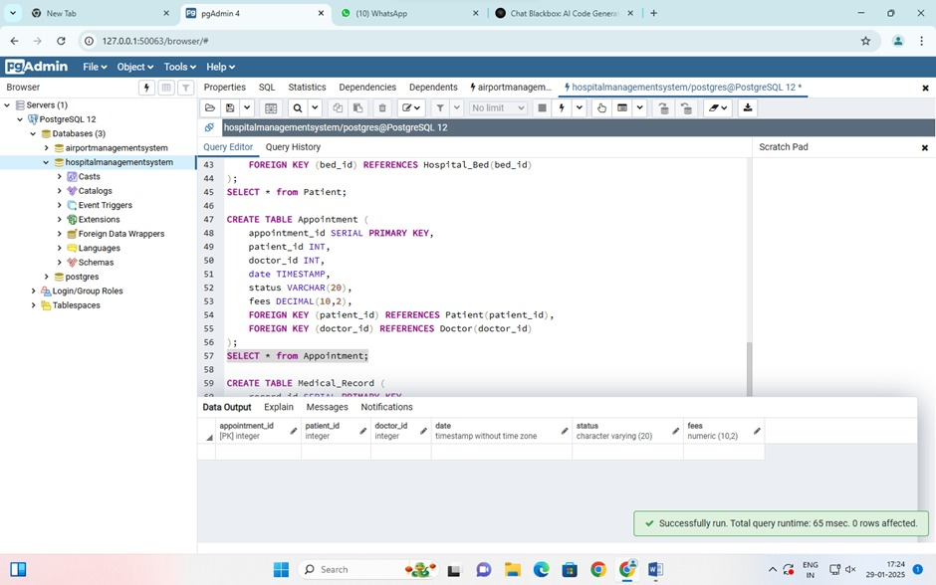
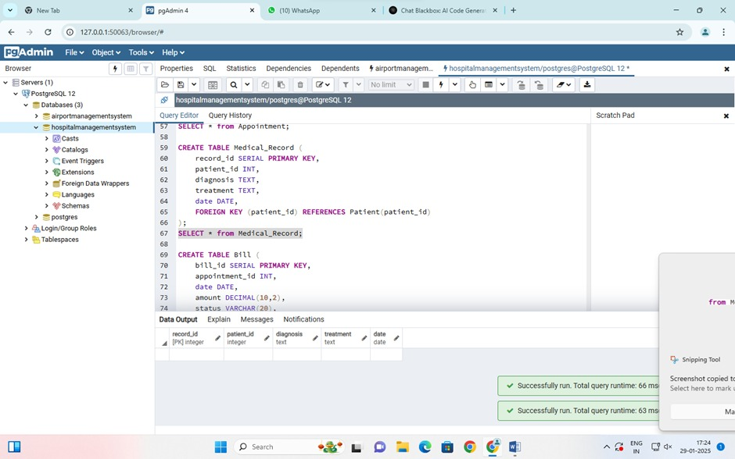
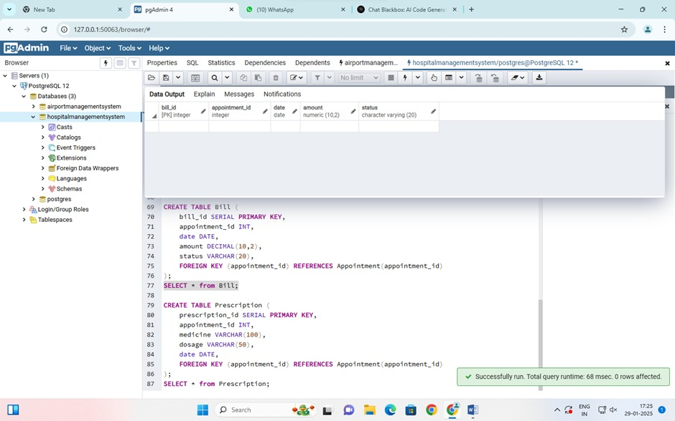
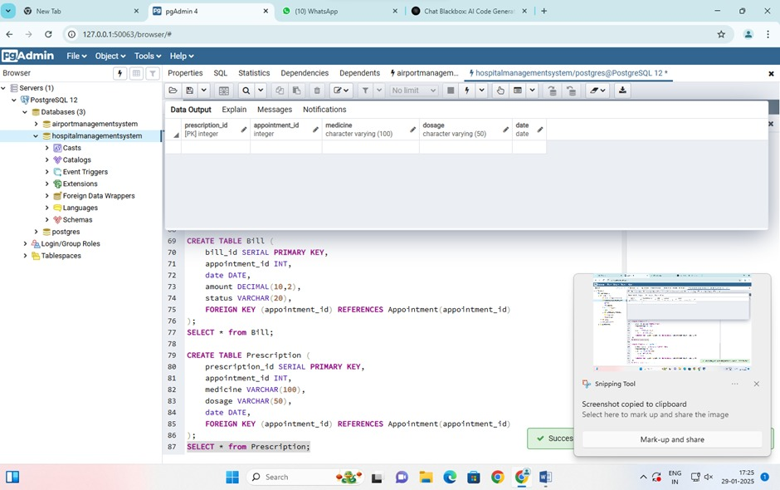

Post Lab Questions:
- Explain in brief the following terms:
  - Database - A database is an organized collection of data, so that it can be easily accessed and managed. You can organize data into tables, rows, columns, and index it to make it easier to find relevant information.

  - Types of databases
- Centralized Database
- Distributed Database
- NoSQL Database
- Cloud Database
- Relational Database
- Network Database
- Object-oriented Database
- Hierarchical Database

  - SQL Data Types
- Numeric Data Types
- Character and String Data Types
- Date and Time Data Types
- Binary Data Types
- Boolean Data Types
- Special Data Types

  - Foreign key - In the relational databases, a foreign key is a field or a column that is used to establish a link between two tables. In simple words you can say that, a foreign key in one table used to point primary key in another table.

- What are the commands to:
- Delete an entire table
Ans. DROP TABLE table_name;

- To view a database

Ans. SHOW DATABASES;
USE database_name;
SHOW TABLES;

- To select & view all the columns
Ans. SELECT * FROM table_name;

- For the given ER model, using DDL command: Write syntax to create CREATE Tables with all possible integrity constraints.

Problem Statement:

A small accounting firm wants a simple HR application that will help it to keep track of its employees, their positions, allowances, salary scales, and which company vehicles their employees drive. The application must keep track of all the positions at the firm, the employees filling these positions, the allowances for these positions, the salary scales for these positions, and the company vehicles assigned to these positions.

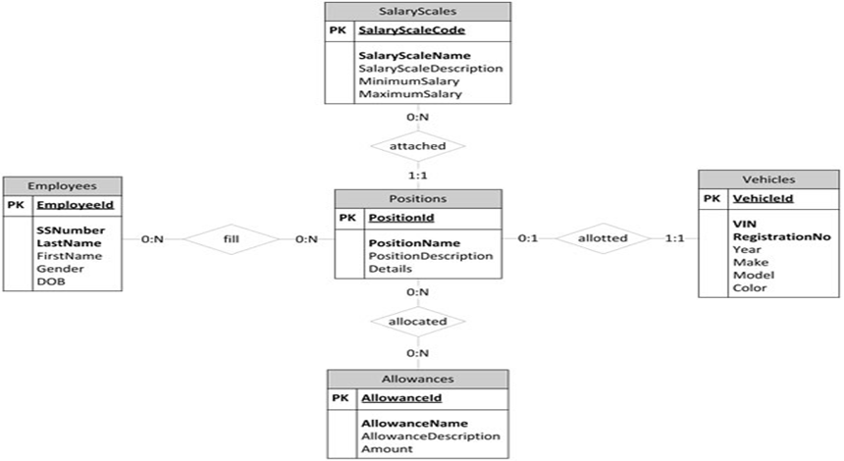

Code-
CREATE TABLE SalaryScales (
SalaryScaleCode INT PRIMARY KEY,
SalaryScaleName VARCHAR(100) NOT NULL,
SalaryScaleDescription TEXT,
MinimumSalary DECIMAL(10, 2) NOT NULL,
MaximumSalary DECIMAL(10, 2) NOT NULL,
CHECK (MinimumSalary <= MaximumSalary)
);

CREATE TABLE Employees (
EmployeeId INT PRIMARY KEY,
SSNumber VARCHAR(15) UNIQUE NOT NULL,
LastName VARCHAR(50) NOT NULL,
FirstName VARCHAR(50) NOT NULL,
Gender CHAR(1) CHECK (Gender IN ('M', 'F', 'O')),
DOB DATE NOT NULL
);

CREATE TABLE Positions (
PositionId INT PRIMARY KEY,
PositionName VARCHAR(100) NOT NULL,
PositionDescription TEXT,
Details TEXT,
SalaryScaleCode INT UNIQUE,
FOREIGN KEY (SalaryScaleCode) REFERENCES SalaryScales(SalaryScaleCode)
);
CREATE TABLE Vehicles (
VehicleId INT PRIMARY KEY,
VIN VARCHAR(20) UNIQUE NOT NULL,
RegistrationNo VARCHAR(20) UNIQUE NOT NULL,
Year_R INT NOT NULL,
Make VARCHAR(50) NOT NULL,
Model VARCHAR(50) NOT NULL,
Color VARCHAR(30) NOT NULL
);

CREATE TABLE Allowances (
AllowanceId INT PRIMARY KEY,
AllowanceName VARCHAR(100) NOT NULL,
AllowanceDescription TEXT,
Amount DECIMAL(10, 2) NOT NULL
);
CREATE TABLE Employee_Positions (
EmployeeId INT,
PositionId INT,
PRIMARY KEY (EmployeeId, PositionId),
FOREIGN KEY (EmployeeId) REFERENCES Employees(EmployeeId),
FOREIGN KEY (PositionId) REFERENCES Positions(PositionId)
);

CREATE TABLE Position_Allowances (
PositionId INT,
AllowanceId INT,
PRIMARY KEY (PositionId, AllowanceId),
FOREIGN KEY (PositionId) REFERENCES Positions(PositionId),
FOREIGN KEY (AllowanceId) REFERENCES Allowances(AllowanceId)
);

ALTER TABLE Positions
ADD COLUMN VehicleId INT UNIQUE,
ADD FOREIGN KEY (VehicleId) REFERENCES Vehicles(VehicleId);

SELECT * FROM SalaryScales;
SELECT * FROM Employees;
SELECT * FROM Positions;
SELECT * FROM Vehicles;
SELECT * FROM Allowances;
SELECT * FROM Employee_Positions;
SELECT * FROM Position_Allowances;

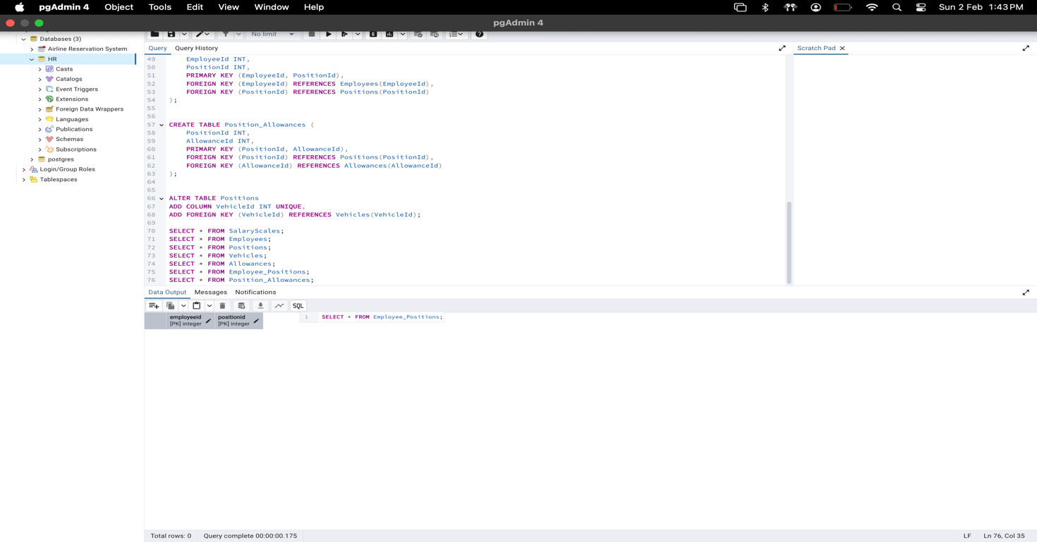
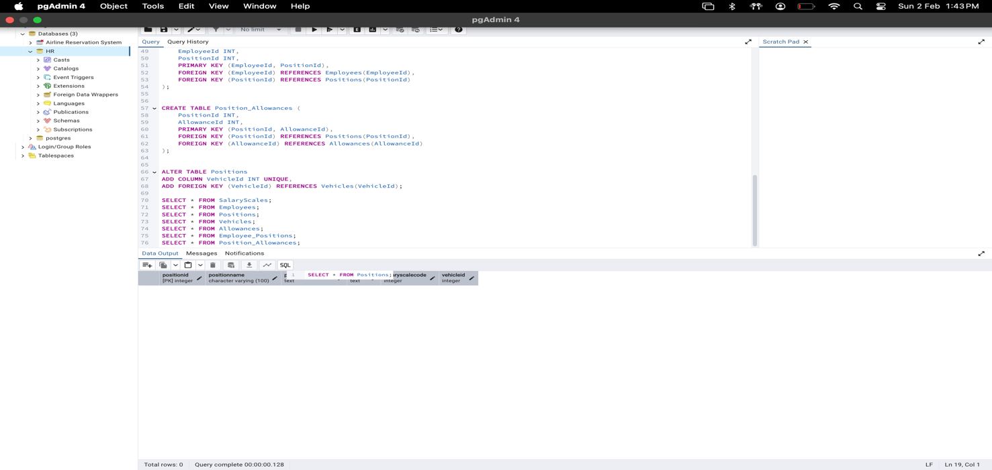
Conclusion:

SQL DDL is essential for defining and managing database structures. Commands like CREATE, ALTER, and DROP help create, modify, and delete tables while maintaining data integrity through constraints.

